**Welcome to the Python Development 🤘**

Python is not just a language, it’s a superpower

In this course, you’ll go from writing your first line of code to building cool projects that’ll make you say, ‘Wow, I did that! 😎’

Whether you’re totally new to coding or just looking to sharpen your Python skills, get ready for an epic journey filled with coding magic, challenges, and lots of fun moments. .

**Python Language Quick Overview**

Python is a high-level, interpreted programming language that is widely used for many different purposes, from web development to scientific computing to machine learning.

There are several reasons why Python is a great choice for many different types of projects:

1. **Easy to learn:** Python has a relatively simple syntax, which makes it easier for beginners to learn compared to other programming languages.
2. **Versatile:** Python can be used for a wide range of applications, including web development, data analysis, artificial intelligence, and more.
3. **Large and active community:** There is a large and active community of Python developers, which means that there are many resources available for learning and solving problems.
4. **Plenty of libraries**: Python has a large number of libraries, including NumPy, pandas, and Matplotlib, which can be used to perform complex tasks with just a few lines of code.
5. **Cross-platform compatibility:** Python can run on multiple operating systems, including Windows, macOS, and Linux, making it a good choice for projects that need to be run on multiple platforms.

**Install Python3 and Vs-Code on a Windows machine**

**Install Python**

If you don't want to use Thonny, here's how to install and run Python on your computer.

1. Download the [latest version of Python](https://www.python.org/downloads/).
2. Run the installer file and follow the steps to install Python
3. During the installation process, check **Add Python to environment variables**. This will add Python to environment variables, and you can run Python from any part of the computer.
4. Also, you can choose the path where Python is installed.

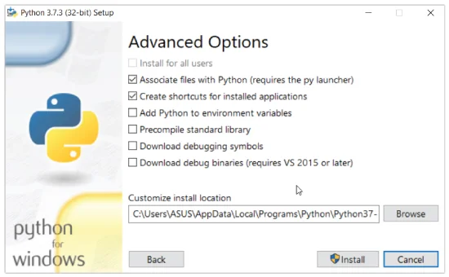

**Note:** For Unix based Operating Systems like Linux and macOS systems have Python pre-installed